**PREPARATION AND MAINTANENCE OF ZOHO BOOKS FOR BRIGHT IDEAS CONSULTING**

**1.INTRODUCTION:**

**1.1 Overview:**

Our team project is “Bright Ideas Consulting”. Bright Ideas are a company specialising in offering help and support to organisations requiring assistance to deliver their development program and ambitions.

consultants help organizations manage change and solve problems so they operate more efficiently and therefore profitably.

**1.2 Purpose:**

**“Bright Ideas Consulting” purpose is** to offer leadership on an interim or short-term basis to drive delivery of your development program and goals.

  To offer high level assistance on projects, programs, staffing or strategic issues.

Bright ideas consulting offers various expert consulting services in India and outside India.

**2.PROBLEM DEFINITION & DESIGN THINKING:**

**2.1 Empathy Map:**

Empathy map describes the says, thinks, does and feel in the topic of “BRIGHT IDEAS CONSULTING.

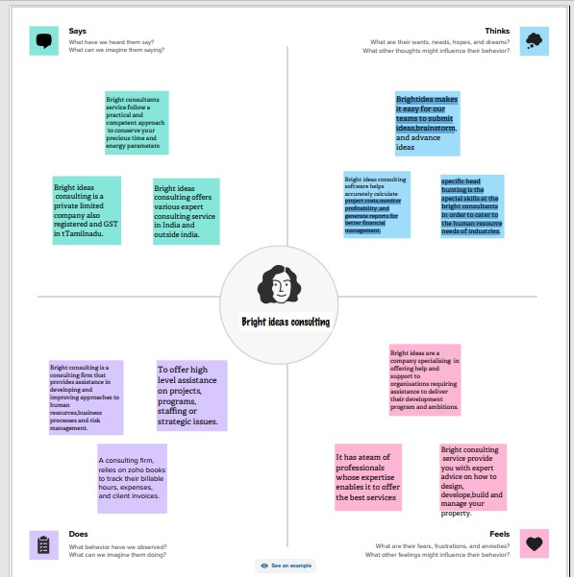

**2.2 Ideation & Brainstorming Map:**

Brainstorming map describes the opinion of the team members in the topic of “BRIGHT IDEAS CONSULTING.

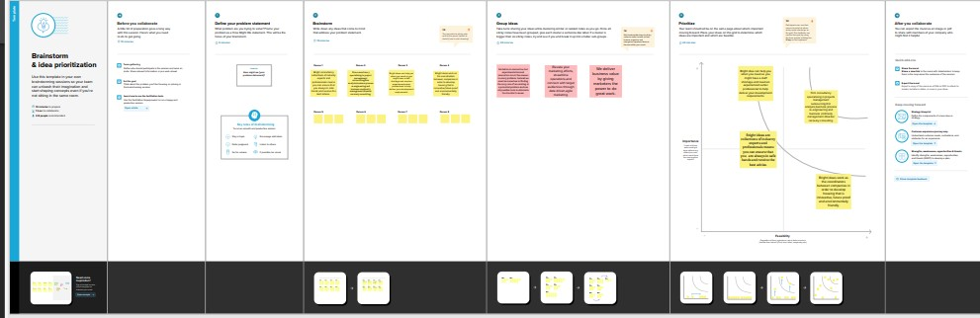

**3. RESULT:**

* In this project we got PROFIT on the profit and loss account.
* In the balance sheet both the ASSET and LIABILITY are tally in the equal amount.

**OUTPUT OF PROFIT AND LOSS:**

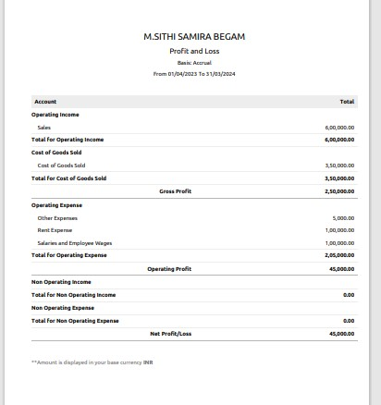

**BALANCE SHEET:**

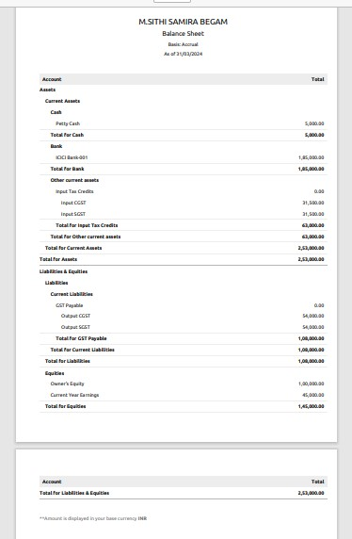

**4.ADVANTAGES & DISADVANTAGES:**

**Advantages:**

* **it's a lot of hard work. Professionals that lack strong work ethics or can't sustain long hours, don't typically succeed in consulting.**
* **This challenging responsibility, when done effectively, is a great source of fulfilment**
* **They need skills to analyse valuable information, your expertise to help them decide, your objective opinion to push them to the top**

**Disadvantages:**

* **They also get disapproval from the people around them due to role confusion or misunderstandings**
* **Some employees are apprehensive in giving them access to company data and insights because they feat that it might hurt themselves.**

**5.APPLICATION:**

**Bright Ideas Consulting (Professional services – Industry)**

**6.CONCLUSION:**

**Bright ideas is committed to helping you realize your event or business vision with our customized partnership options. contact us today to learn more about how we can help you create a successful event or achieve your desired outcomes.**

**7.FUTURE SCOPE:**

**The future of consulting is all about resilience and start up. The future of consultancies in India based on the current and future prospects of the various sectors; will have critical success factors. Increased demand for consulting services by domestic and foreign firm sector in India is consistently growing**. **The future of consulting should be predicated on greater senior partner engagement because increasingly there are no "generic" projects. Clients can no longer afford to waste time and money on junior consultants data crunching and trying to come up to speed with their business**.